Technical description of the Ondřejov Coelostat And Spectrograph in Laboratoř Borise Valníčka

(OCAS-LBV)

1
Contents

Introduction ……………………………………………………………………………………. 3

Device description …………………………………………………………………………... 3

Coelostat ……………………………………………………………………………………..... 4

Pointing telescope …………………………………………………...…………………….... 6

Pointing camera ……………………………………………………………...………………. 7

Image selector …………………………………………………………………………….….. 7

Slit-Jaw camera …………………………………………………………………………….. 10

Spectrometers ………………………………………………………………………….……. 12

References ……………………………………………………………………………………. 13

2

Introduction

This text is a technical description of the Ondřejov Coelostat And Spectrograph (OCAS-LBV), which is located in Laboratory of Boris Valníček. The instrument is designed to measure the spectral flux of the optical continuum in the active region on the Sun.

Device description
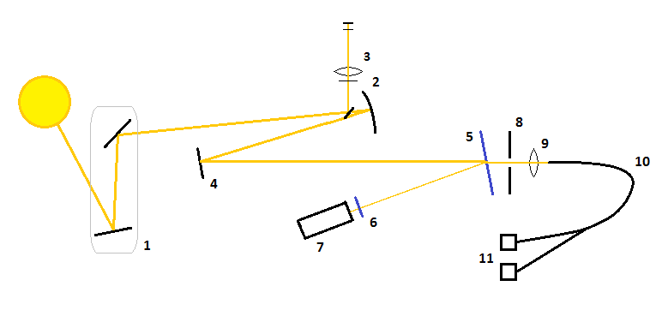

Device description:

1- coelostat
2- primary mirror
3- pointer telescope
4- plane mirror
5- reflective plate
6- filter
7- telescope with SJ camera
8- rotating wheel with diaphragms
9- lens
10-optical fiber
11-spectrometers
3

Coelostat

The spectrograph is placed in a room of dimensions 7,85 times 3,50 times 2,66 meters, which is situated in the first storey of the solar department building at the observatory in Ondřejov. The solar light is cast into this room by a coelostat (1) situated on a tower at an altitude of 5 m detached from the building.

The coelostat consists of two mirrors. Mirror diameters of the coelostat are 360 and 280 mm. The primary mirror can be rotated around the polar axis and is situated on the movable support. The secondary mirror is placed on another movable support that makes possible horizontal movement of the mirror. The mirror is attached to a construction that makes it possible to move vertically. A clockwork is connected to the mirrors, so they can follow the Sun during the day.

The coelostat is covered by a half-cylindrical double roof with length 3,8 m, width 2,5 m and maximum height 1,35 m with a very good thermic isolation on a steel construction with an openable circular view with a diameter 40 cm. The roof can be shifted on rails close to the southern wall of the building, so that any turbulent motions in the close vicinity of the wall cannot disturb the optical path of the solar beams. On the front side there is a sliding door, which can close the roof. On the sides the coelostat is covered by a 92 cm high wall.

The solar beam coming from the Sun falls on the primary plane mirror and then it is reflected on the secondary mirror of the coelostat. After that it is going throw the openable circular view in the cylindrical roof and throw the hole in the wall with a diameter 30 cm to the room with the spectrograph. The center of the hole is located at an altitude of 7,7 m above the ground and 1,67 m above the floor of the room. It falls on the objective spheric mirror (2) of 230 mm diameter and 1350 cm focal length. After a reflexion on the plane mirror (4) of 150 mm diameter, the objective forms a focal image of the Sun (125-6 mm in diameter), which is located in the same height as the hole in the wall, main and plane mirror.

4

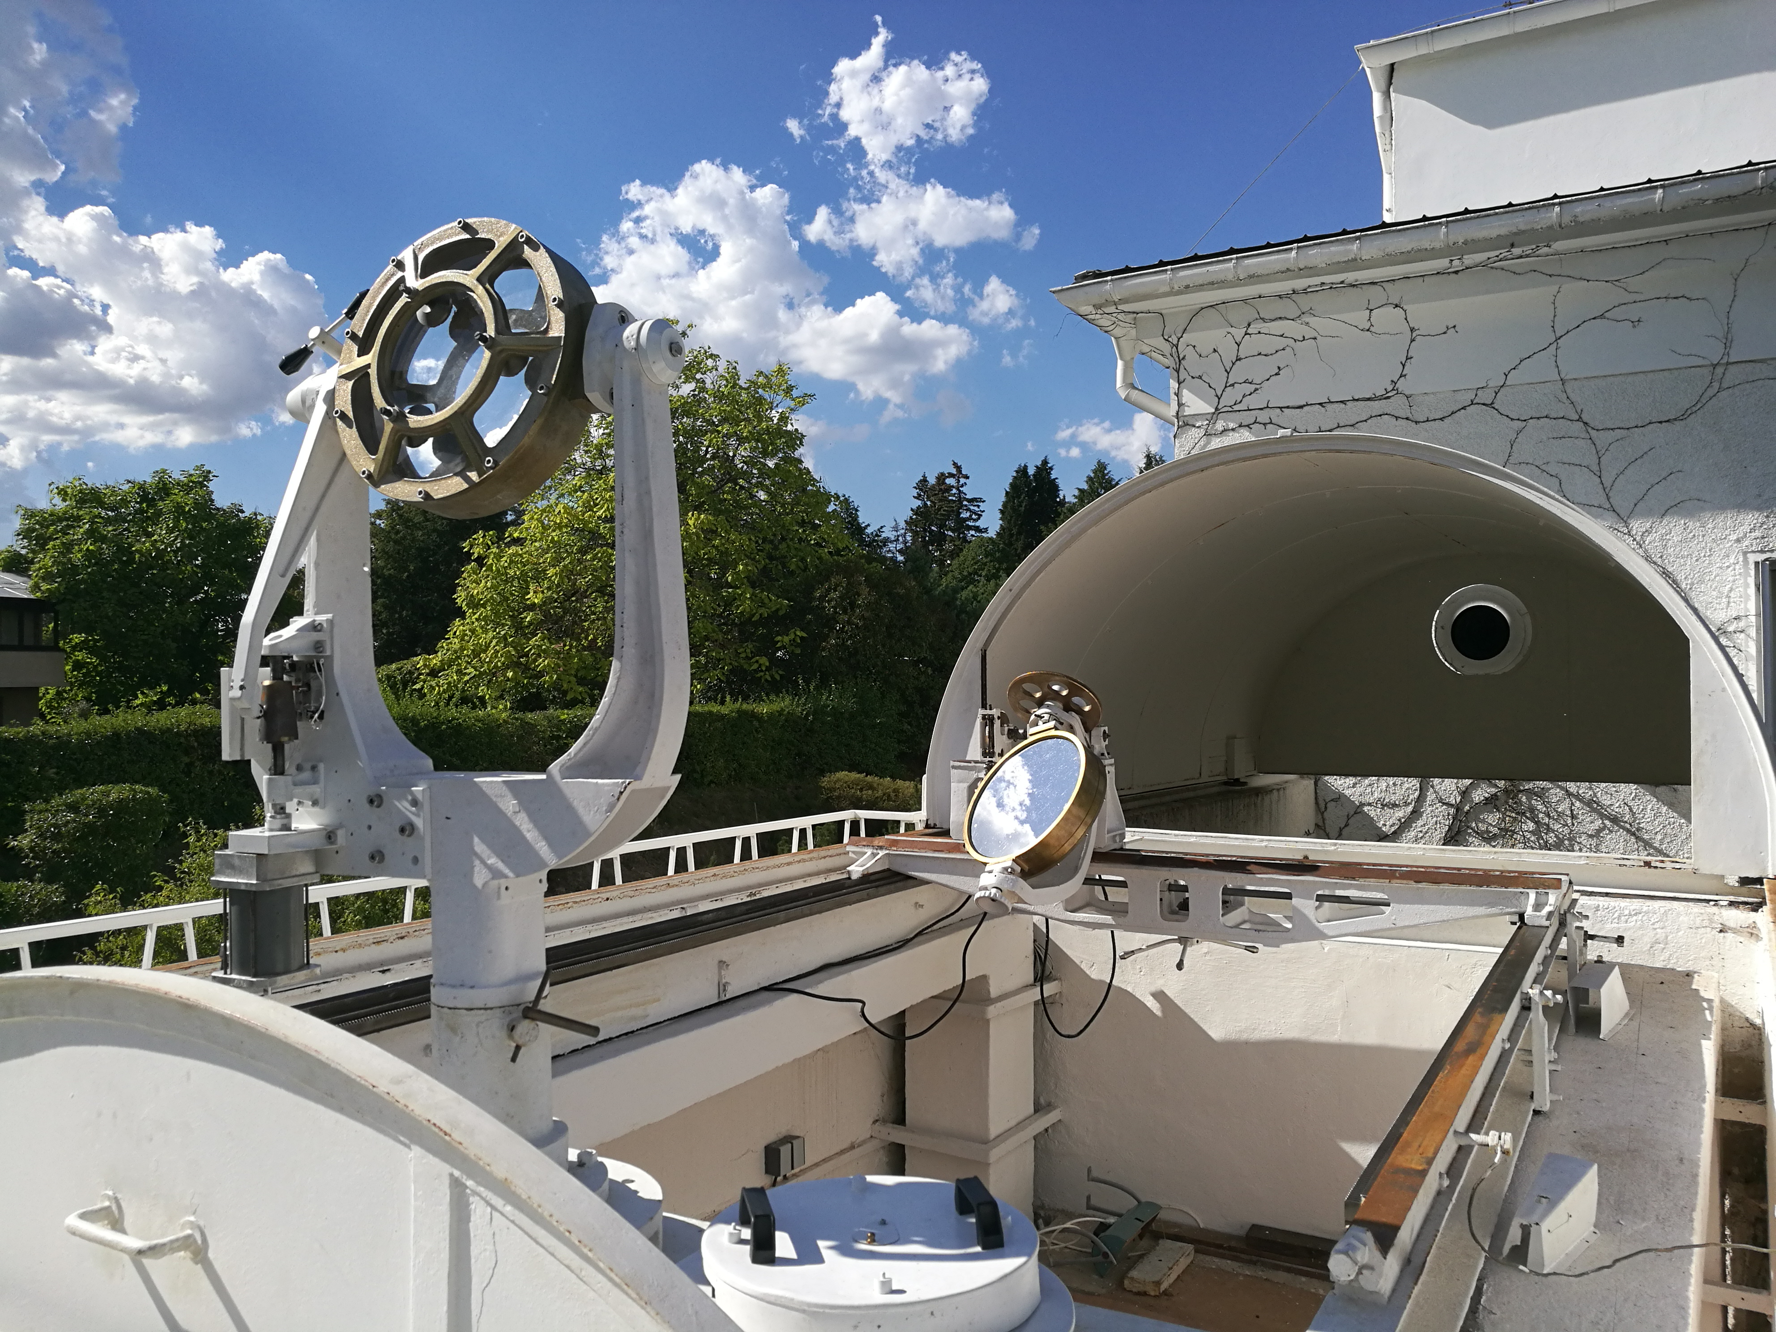

Figure 1: Coelostat: To the left there is the secondary mirror and in the center there is the primary mirror. In the background is the roof, which can be shifted on rails.

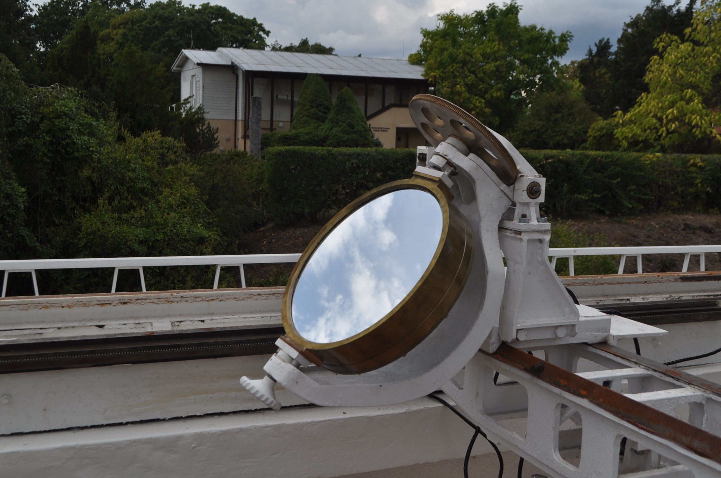
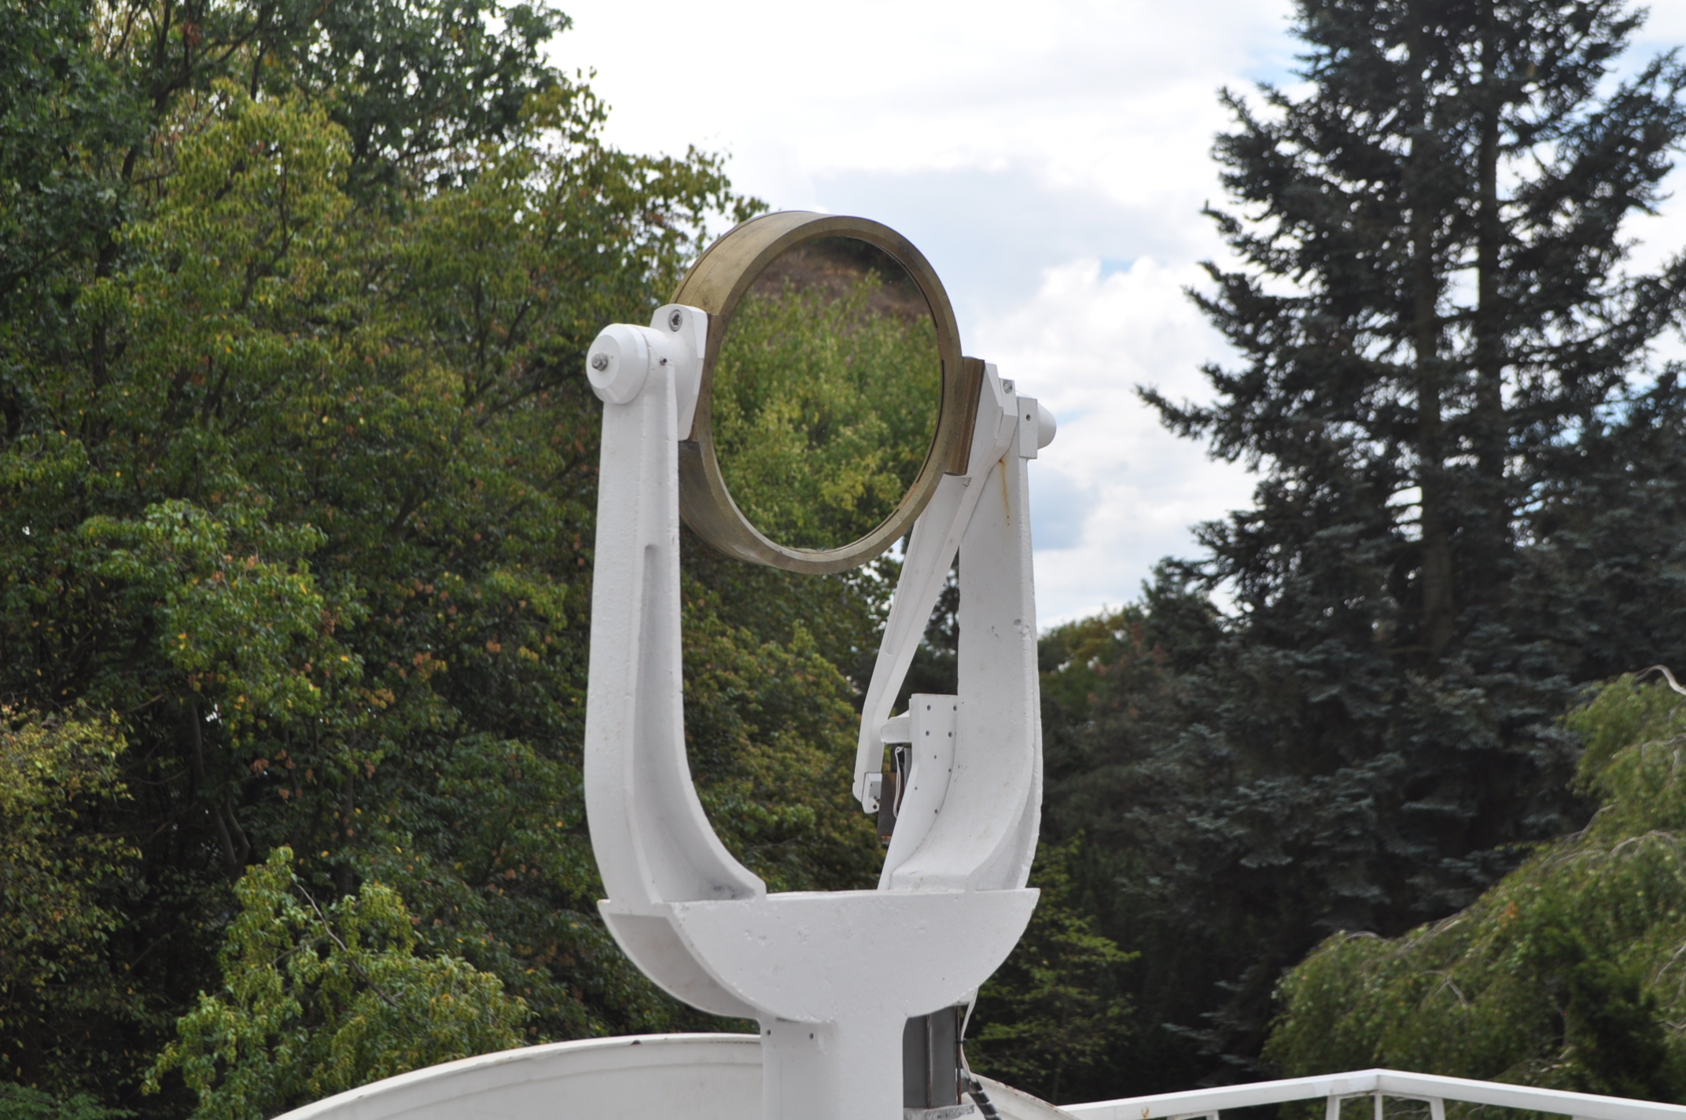

Figure 2, 3: primary mirror (on the left) and secondary mirror (on the right)

5

Pointer telescope

The light from the coelostat is going towards the objective spheric mirror. In front of the objective spheric mirror of the telescope there is a small mirror sloped at an angle of 45 degrees with the diameter of 50 mm. This mirror reflects a part of the light that comes from the coelostat through the hole in the wall on the objective mirror. The light is reflected up into the pointer telescope (3) William Optics Zenithstar 80 with a diameter of 80 mm and focal length of 480 mm in the height of 185 cm above the floor. On the top of the telescope there is a pointing camera.

The rest of the light, which is not going to the pointing telescope continues around the small sloped mirror on the main spherical mirror of 230 mm diameter. From this mirror, it is reflected and focused on a secondary plane mirror of 150 mm diameter located 6,45 meters from the main mirror. Then the light is reflected to the glass wedge and the rotating wheel with diaphragms.

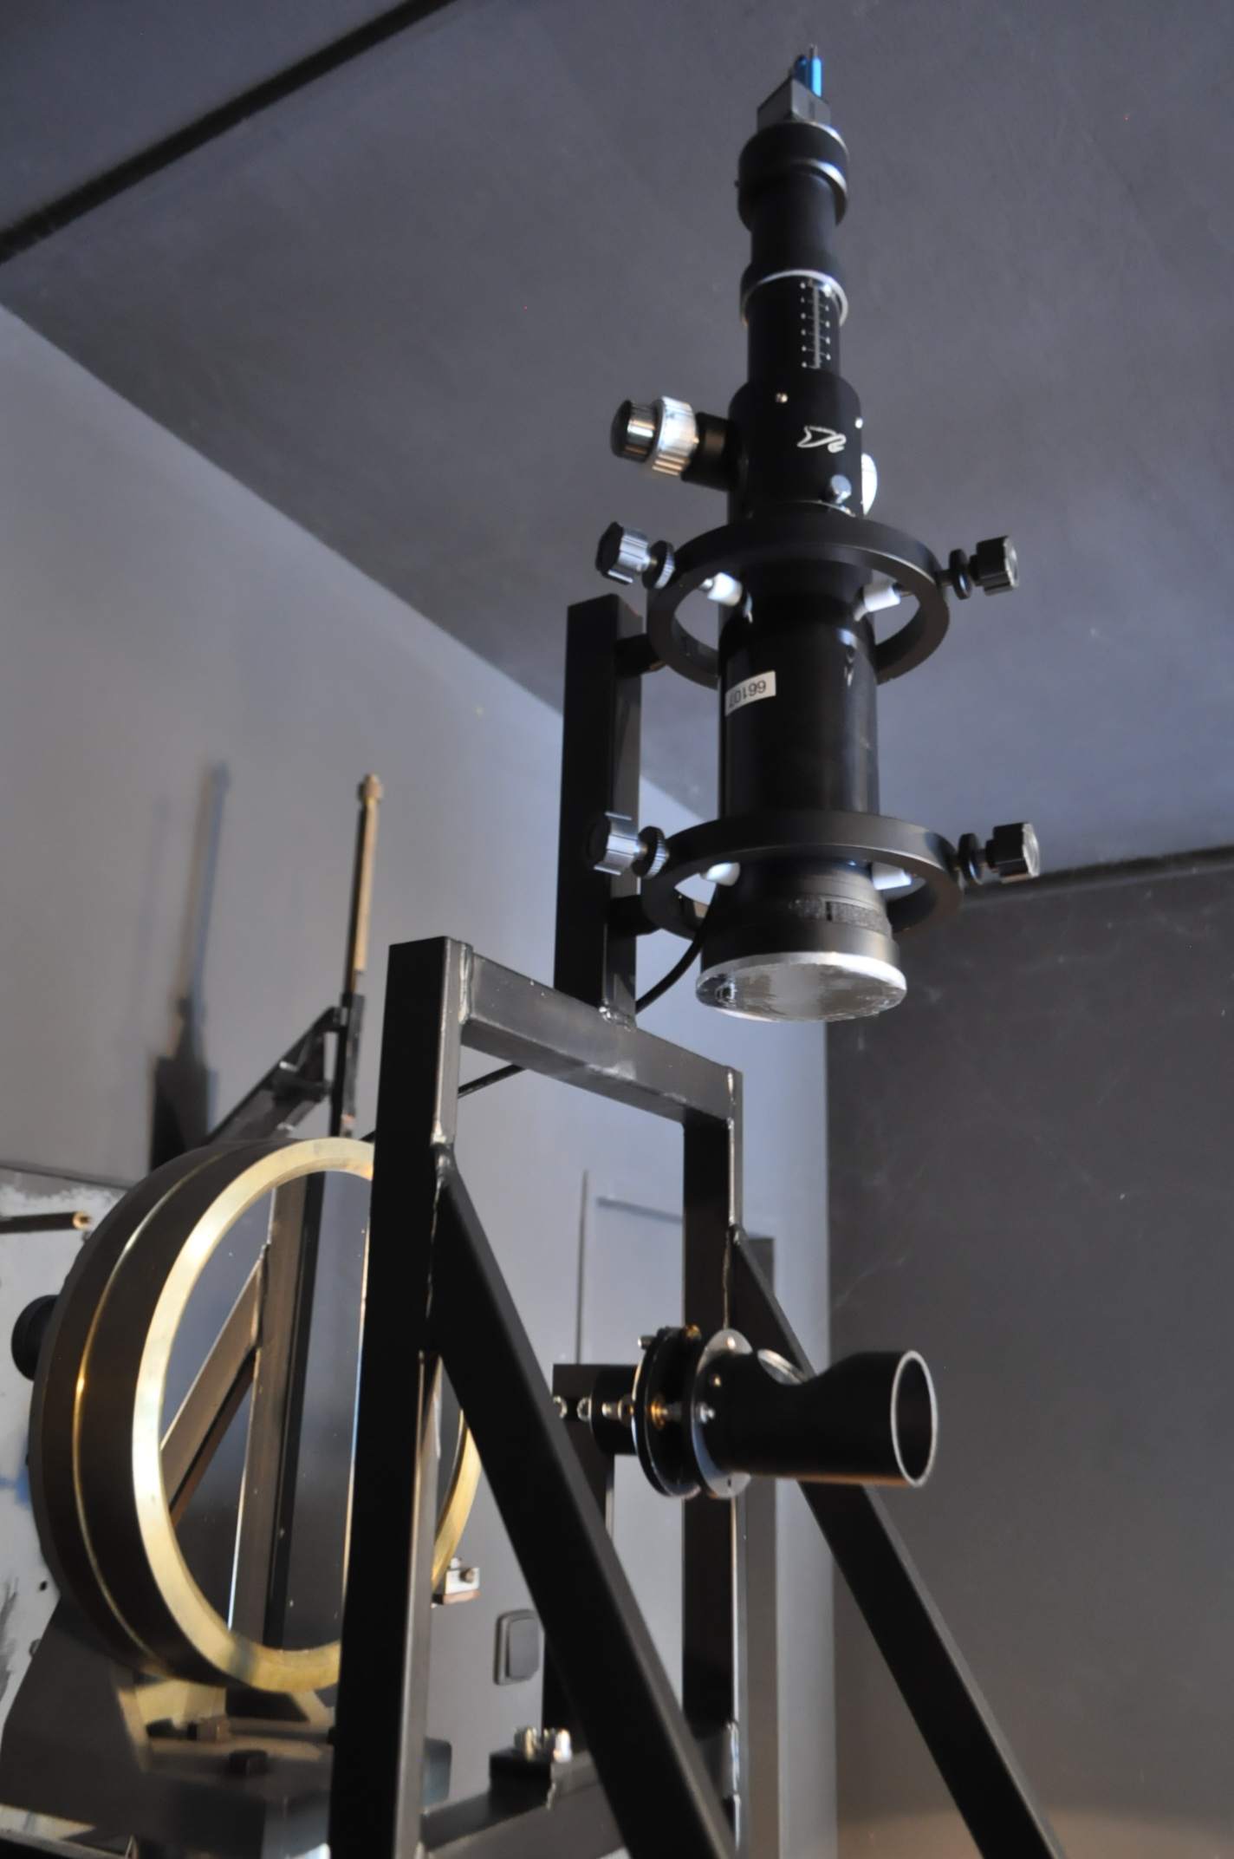

Figure 4, 5: At the top of the figure is the pointer telescope with diameter of 80 mm. The pointing camera is on the top of the telescope. Under the telescope there is small sloped mirror. The main spherical mirror is located behind the small mirror on the left side of the image. It is reflecting the light to the secondary mirror (down).

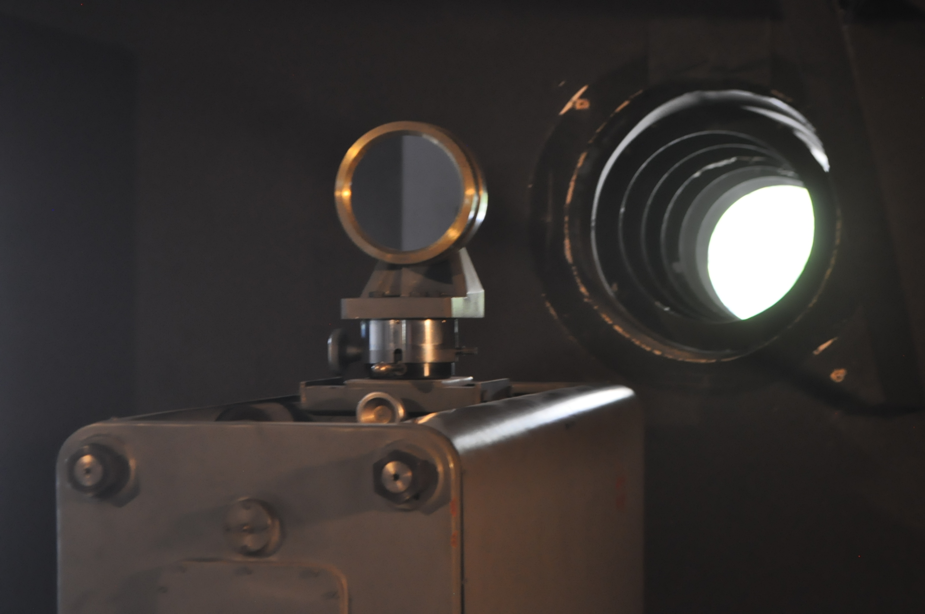

6

Pointing camera

Pointing camera (IDS camera) is a device, which captures the image from the pointer telescope. The camera is used to guide the device to the observed area and to determine its coordinates. The camera is controlled via the computer.
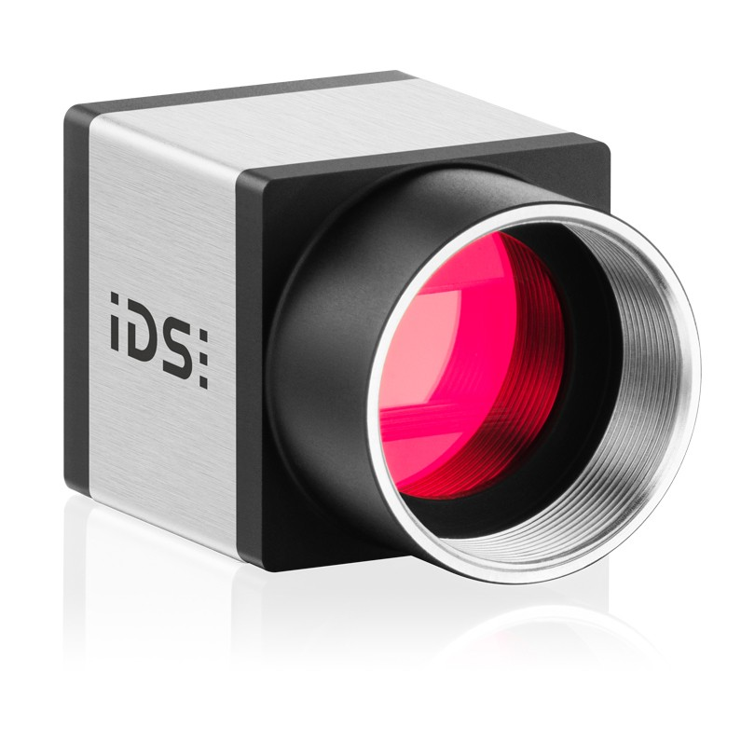
The USB 3.0 industrial camera UI-3180CP Rev. 2.1 with 1" global shutter CMOS sensor PYTHON 5000 from ON Semiconductor with full resolution of 2592 x 2048 (5.31 MPix, up to 73.0 fps) can be switched to the square 2K x 2K format to reach higher frame rates. With a unique AOI feature (horizontal and vertical read-out), the industrial camera reaches more than 1000 fps. It achieves 260 fps in common optical 1.3 MP class, e.g. by using the subsampling feature. The CMOS camera is ideal especially for applications in the field of microscopy. Available as monochrome or colour version.

Figure 6: Pointing camera

Image selector

Image selector is a device which consists of a rotating wheel with diaphragms (8), a lens (9) and a reflective plate (5). It is situated next to the main mirror on the wall in the distance approximately 7 m from the secondary mirror in the same altitude like the main spherical mirror.

Turning the wheel is controlled via the computer. The selector makes a circular area around the observed region. By selecting one of the seven diaphragm with an entrance hole in its center, the size of the area from which the spectrum is obtained can be changed.

7
diaphragm number | size of diaphragm (mm) | angular size of the observed area (“)
1 | 4 | 61
2 | 13 | 200
3 | 6 | 92
4 | 15 | 230
5 | 10 | 154
6 | 18 | 276
7 | 20 | 307

Table 1: Sizes of the diaphragms and angular sizes of the are from which is the spectrum obtained.

On the rotating wheel a focal image of the Sun is formed. The diameter of the solar disk at the focal plane is 125 mm. Part of the light is reflected from the reflective plate to SlitJaw camera, the rest is going throw the selected diaphragm.
Behind the wheel with diaphragms there is a converging lens. The light that has passed through the diaphragm is going to this lens, which is focusing it into the optical fiber.
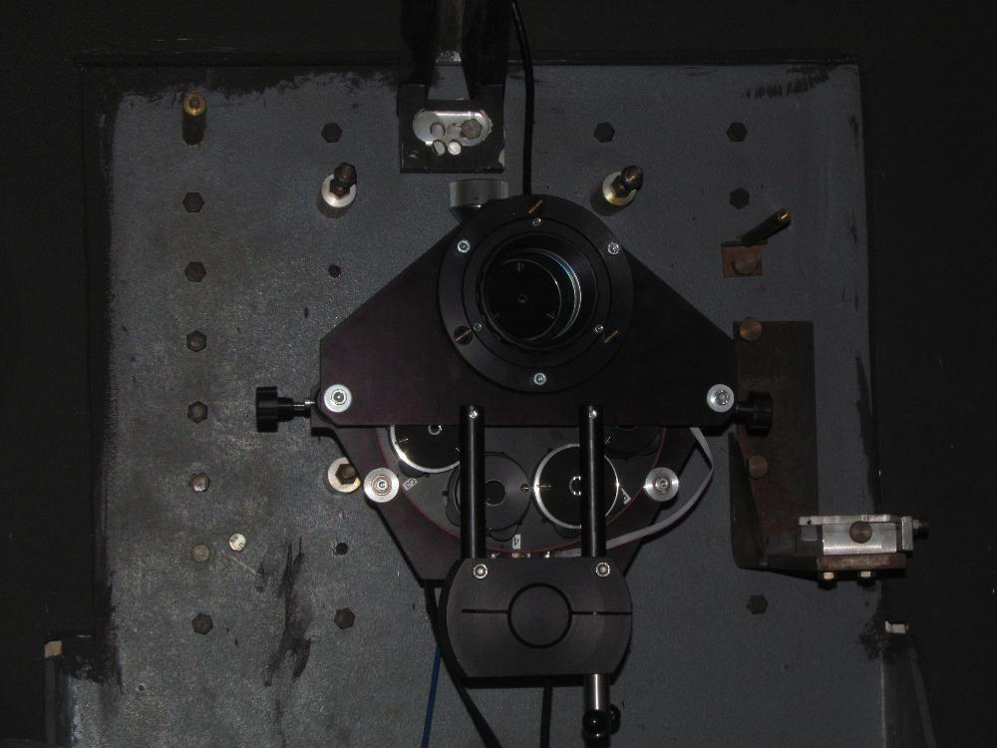

8
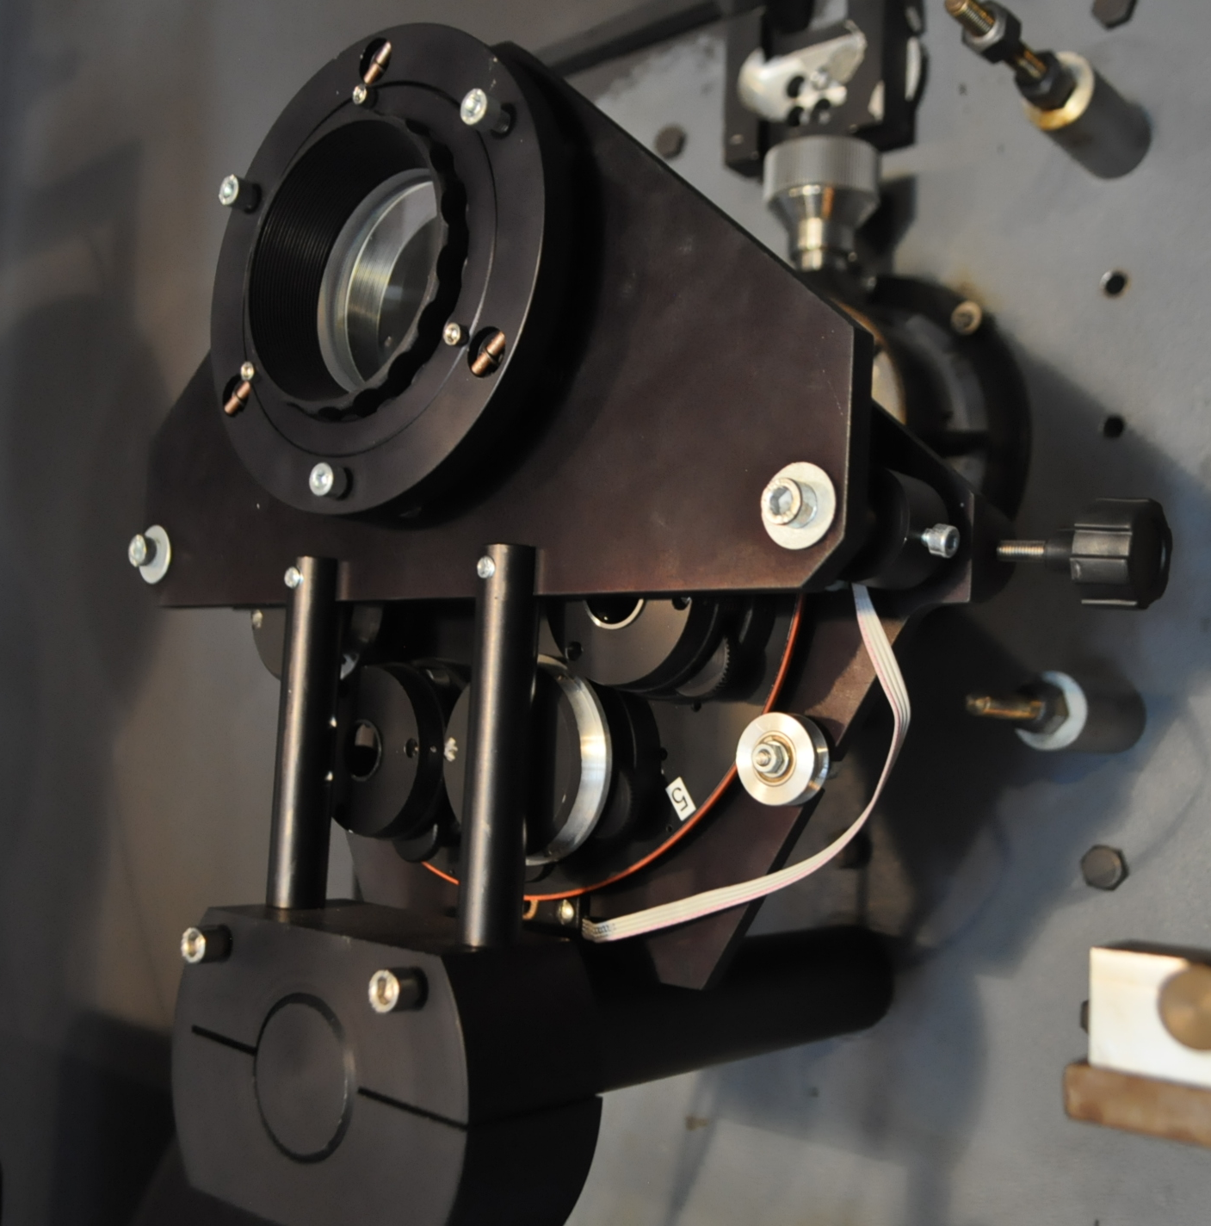

Figure 6, 7: The wheel with the diaphragms. The selected diaphragm is on the top.
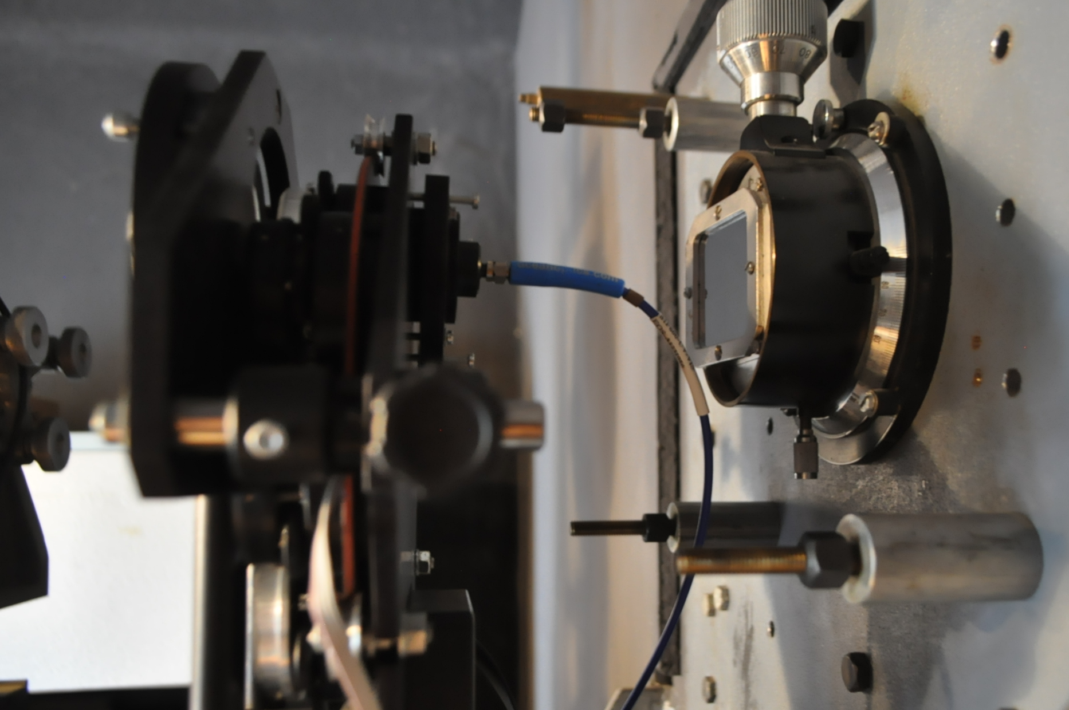

Figure 8: wheel with the diaphragms, optical fiber and the reflexing plate with the entrance slit of the former large optical spectrograph
9

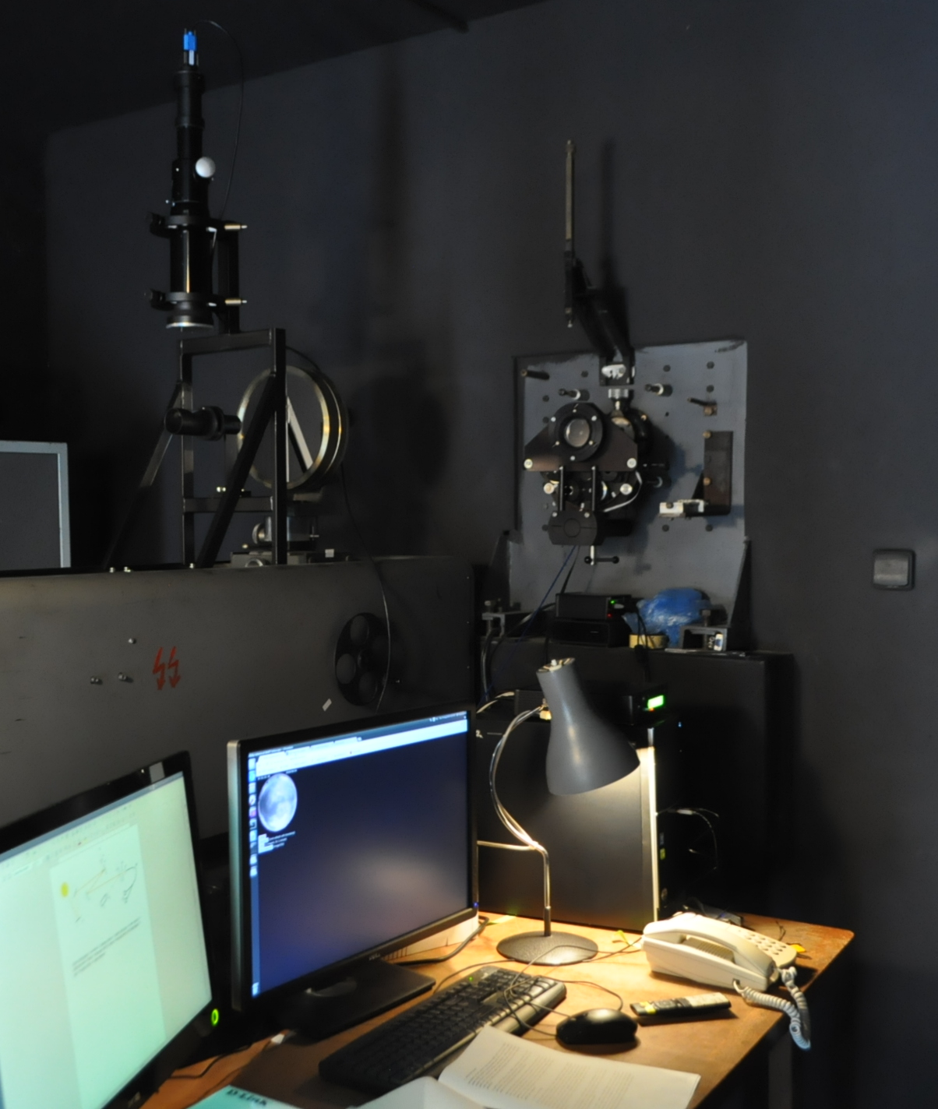

Figure 9: pointer telescope (on the left), main spherical mirror and wheel with diaphragms (on the right)

SlitJaw camera

SlitJaw (SJ) camera ZWO ASI174MM is attached to the telescope Coronado Personal Solar Telescope (7) of 40 mm aperture and 400 mm focal length with a H alfa filter (6). The bandwidth is less than 1 Å. The distance between the telescope and the Image selector is 2,4 m. The telescope captures part of the light that has not passed through the image selector and was reflected from the reflective plate. The edges of the diaphragms are polished so they are clearly visible on the camera images. The camera senses the observed area. It is controlled via the computer.

10
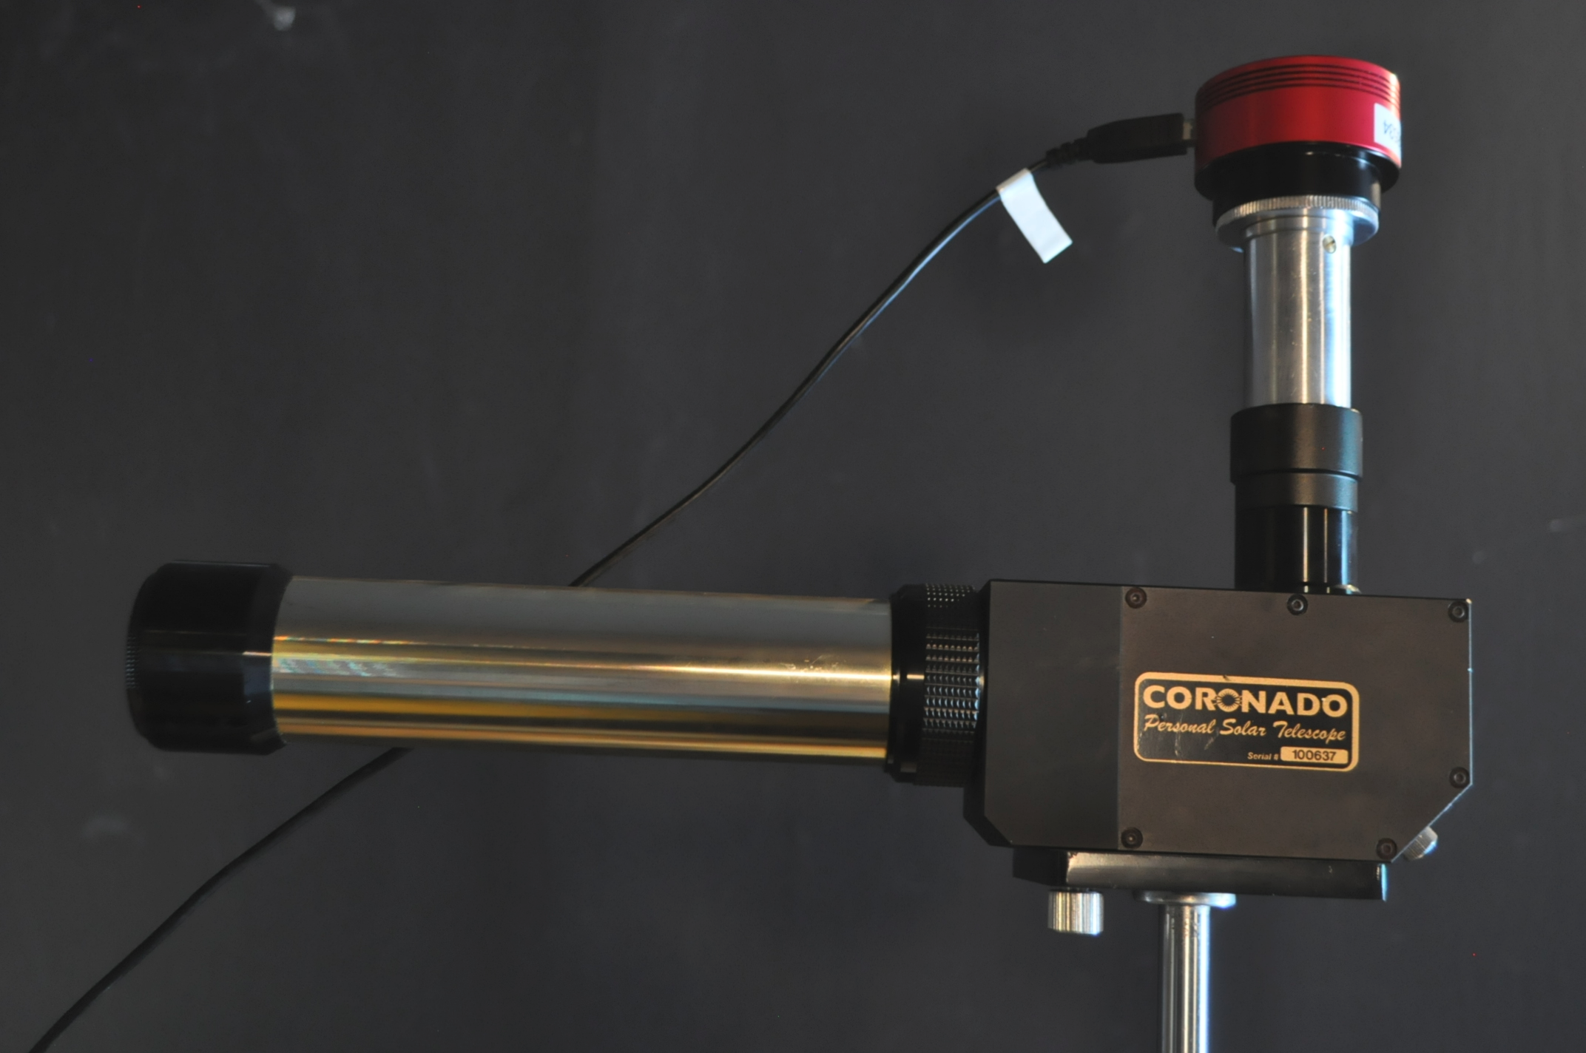

Figure 10: Coronado PST telescope with SlitJaw camera

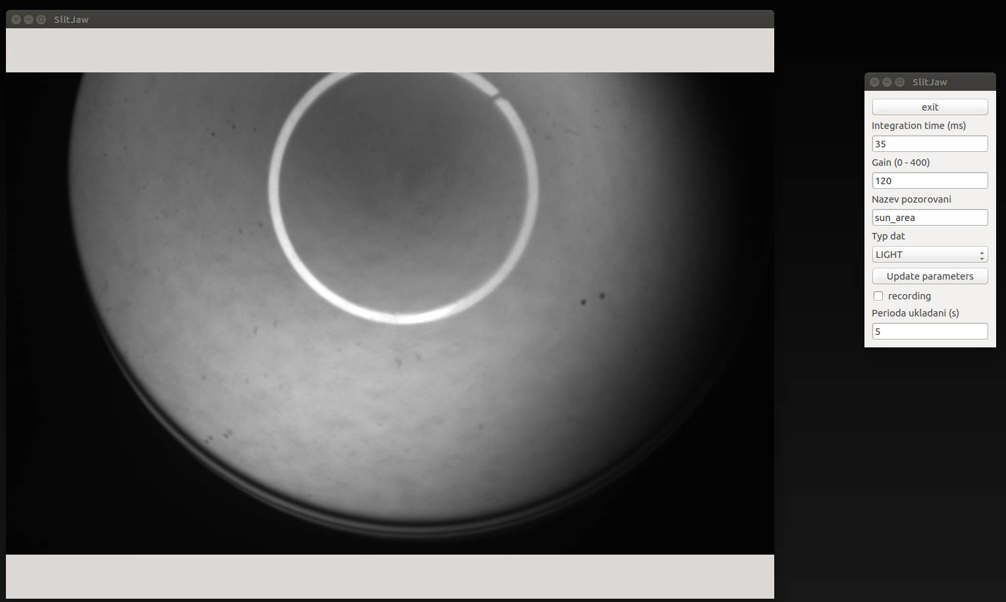

Figure 11: an image of the active region on the Sun from SJ camera

11

Spectrometers
The light that has passed through the diaphragm is focused by the lens (9) into the optical fiber (10). The fiber is divided into two fibers. They lead the light to two high-resolution spectrometers HR4000 (11) made by a company Ocean Optics. The wavelength ranges of the spectrometers are 350 – 485 nm and 477 – 930 nm. The spectrometers have a CCD detector with 3648 pixels.
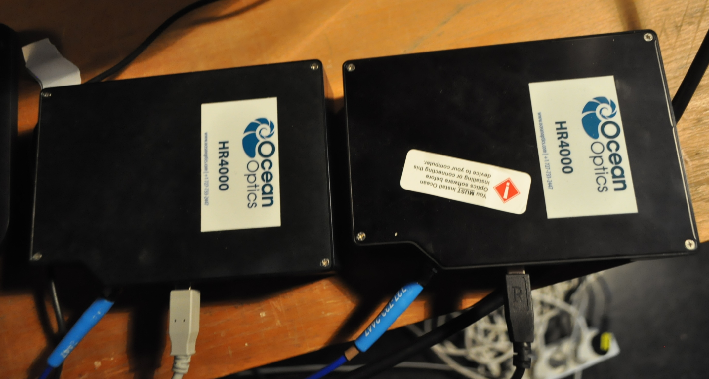

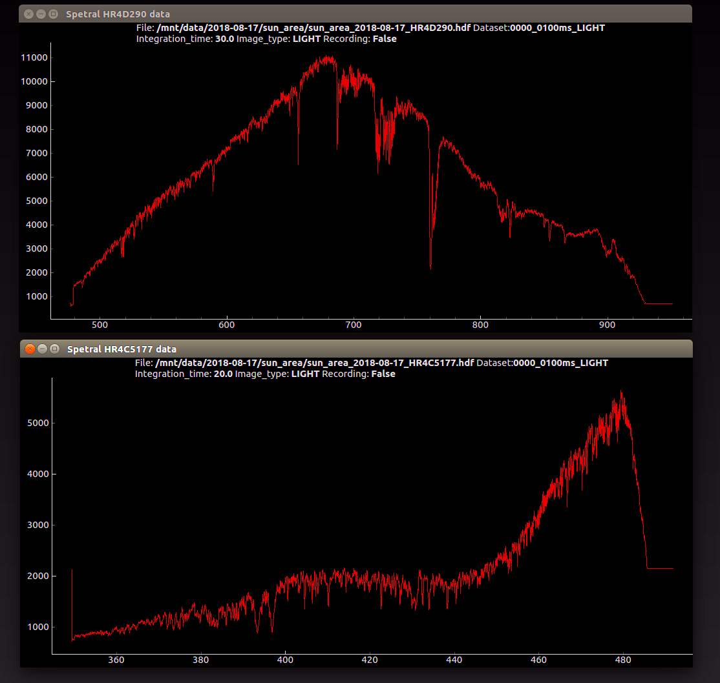

Figure 11, 12: spectrometers and spectra from the spectrometers
12

References

Valníček, B.; Letfus, V.; Blaha, M.; Švestka, Z.; Seidl, Z., 1959, Bulletin of the Astronomical Institute of Czechoslovakia, vol. 10, p.149, The flare spectrograph at Ondřejov

https://www.astromart.com/classifieds/astromart-classifieds/telescope-refractor/show/william-optics-zenithstar-80-sale-pending-300769
https://en.ids-imaging.com/store/ui-3180cp-rev-2-1.html
http://www.star.bris.ac.uk/bjm/solar/telescope.html
https://oceanoptics.com/

13

